Carbon Border Adjustment Mechanism (CBAM)
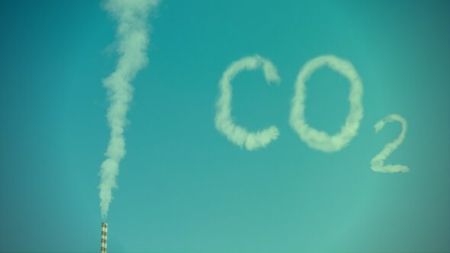
Picture: Gabriela Cydejko / BiznesAlert.pl
On March 10, 2020, the European Parliament adopted a resolution on the Carbon Border Adjustment Mechanism (CBAM). The so called “carbon border tax” has thus became one of the focal points of the European Green Deal. On July 14, 2021, the European Commission presented a draft regulation that defines the framework for the operation of border tax. It is to apply from January 1 2023 onwards, and is supposed to prevent the shifting of production, especially high-carbon industry, to countries where companies do not pay for greenhouse gas emissions (so-called ‘carbon leakage’) and to level the chances of EU and non-EU producers. An additional fee is to be levied on goods imported into the EU, the production of which is associated with high CO2 emissions. The new tax is to cover only selected goods from the following categories:
- cement
- electricity
- fertilizers
- iron and steel
- aluminum
The regulation in question will encourage producers in non-EU countries to green their production processes in order to profit from trade with Europe. This regulation will have direct effects in every EU Member State, but the tax revenues are to go to the fund for the recovery of the EU economy hard hit by the COVID-19 pandemic. The profits from its introduction are estimated between 5 and 14 billion euros per year.
Optimists count that the EU-planned duty will contribute to globalization of environmental regulations and standards. But there are also fears that it will become a tool of unfair competition and increase the cost-effectiveness of production in countries with the highest developed economies (with the low-emission industry). CBAM will not be required from countries that decide to introduce their own climate policy modeled on European. But some EU partners need a lot of time to adapt and reduce their emissions, and thus they can start losing in comparison to European producers.
Doubts from the European perspective have also been voiced. Foreign exporters will pay CBAM only for their export to the EU, but their production aimed at other markets will still be free from climatic fees. For this reason, it is important that a free pool of emission allowances for EU producers, together with RES support, has been maintained in the EU. The lack of equivalent mechanisms will continue to financially motivate consumers to buy "high emission" products, imported from third countries that do not apply the same ambitious climate policy. In consequence, this can lead to an increase in global emissions instead of their limitation.
Poland is interested in obtaining even greater competitiveness in the chemical industry and production of artificial fertilizers, but also sees losses related to the introduction of CBAM. Recent pro-efficiency investments in Poland and other countries from Central and Eastern Europe very much raised the cost of further investments, and thus enterprises will soon be unable to finance energy transformation (due to continuing high cost of technology and efficiency incomparable with traditional energy sources). "When omitted, those factors may lead to a situation where the EU industry ceases to exist, and the impact of industry on the environment will be decided by countries that have previously showed small ambitions in environmental aspect. Bearing in mind the challenges that EU producers must face, especially those from Central and Eastern Europe, maintaining a free pool of emission allowances creates a chance to maintain competitiveness towards non-EU producers", summarizes Dr. Grzegorz Kądzielawski, vice president of the Management Board of Grupa Azoty S.A., leading Polish chemical industry company, second largest producer of mineral fertilizers in Europe.

Sources:
https://www.wnp.pl/energetyka/unijny-podatek-weglowy-nie-ma-juz-odwrotu,428410.html
https://www.wnp.pl/energetyka/parlament-europejski-poparl-podatek-weglowy-na-granicach-unii,455239.html
https://studio.pwc.pl/aktualnosci/alerty/graniczny-podatek-weglowy-juz-od-2023-r
https://biznesalert.pl/cbam-samobojstwo-gospodarcze-europy-fit-for-55-polska-energetyka-klimat/
https://serwisy.gazetaprawna.pl/ekologia/artykuly/8211992,konferencja-klimatyczna-w-glasgow-zielony-ekoprotekcjonizm.html
https://biznesalert.pl/raport-cbam-czyli-ochrona-klimatu-i-biznesu/
https://www.plastech.pl/wiadomosci/Grupa-Azoty-apeluje-o-rowne-warunki-konkurowania-16747

