經濟部推動綠色貿易專案辦公室
商情處理單
所蒐集商情資訊將刊登於綠色貿易資訊網項下國際商情專區，爰請貴中心回傳商情時協助填寫以下欄位，俾利後臺上稿作業，謝謝您的合作。
＊為必填欄位
No | 欄位名稱 | 欄位內容說明
1 | 標題＊ | Green energy in Ukraine will increase by 5 times, and the use of coal will be reduced by 2.5 times, - Razumkov Center
2 | 國家區域＊ | Ukraine
3 | 資訊類別＊ | 說明：此為後臺分類選項，請勾選商情之資訊類別：  □綠色認證資訊  - 綠色商機交換  □綠色技術新知  □企業綠色資訊  □企業綠色採購  □政府綠色採購  □國際綠色新證
4 | 商品類別＊ | 說明：此為後填分類選項，請勾選商情之商品類別：  □化學品  □水資源/土壤地下水/海洋  □照明設備  □碳交易/溫室氣體/空氣汙染  □碳補獲與封存  □紙類/塑膠/鋼材及其再生製品  □綠建築/綠建材  □綠色紡織  □綠色金融  - 能源與再生能源  □航空與海運  □車輛、路上運輸與物流業  □電機/電子/機械設備  □食品與農產品  □其他/所有產品
5 | 新聞日期＊ | 2017/07/13
6 | 商情內容＊ | The Alexander Razumkov Ukrainian Center for Economic and Political Studies predicted the energy balance of Ukraine for the next 15 years, according to which the share of green energy in the balance will increase by 5 times - to 25%, and the share of coal will decrease by 2.5 times - to 13%.  Shares of gas and nuclear power in the consumption of primary energy remain approximately at the current level, respectively 30 and 25%. Experts also expect that the share of petroleum products will significantly decrease - up to 7%.  "Although the value of coal will gradually decrease. It will be replaced mainly by renewable energy, but the coal industry will play a prominent role in the Ukrainian energy sector until 2035. First of all for thermal generation, which performs, among other things, an important function of capacity maneuvering". This opinion was expressed by Vladimir Omelchenko, Director of Energy Programs at the Razumkov Center, during the presentation of the study “The Role and Place of Ukrainian Energy in World Energy Processes” at the Institute for European Politics.  Recall that the event was held on October 17, 2018 at the Institute for European Open Society Policy (OSEPI), in Brussels (Belgium).  The speakers were Torsten Wollert, head of the group on energy and the environment of the Support Group for Ukraine in the European Commission and Christian Egenhofer, head of the Energy and Climate program at the Center for Energy Research.
7 | 資料來源＊ | https://ukranews.com/news/590481-zelenaya-ehnergetyka-v-ukrayne-uvelychytsya-v-5-raz-a-yspolzovanye-uglya-sokratytsya-v-25-raza
8 | 圖片檔案 | 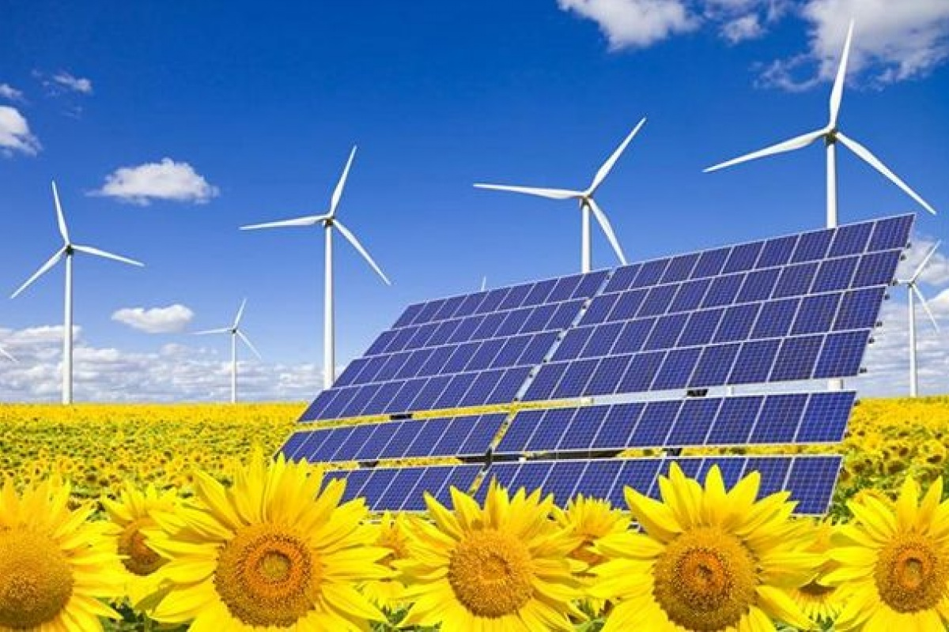
9 | 檔案下載 | 說明：若有相關檔案提供，檔案須小於 8 MB，以pdf檔為主

